Name: Sania Rahate Section: B(B1) Prn no.: 21070521069

**Problem Statement1 :** Generate a model for Covid 19 with symptoms of parameters like fever, cold, shivering, weight loss, generate 100 model data with random values for each parameter and order by parameter lowest to highest in display based on the input parameter.

# Imports:

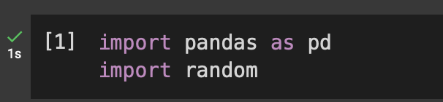

* + Pandas is a python library used for data manipulation and analysis. Here, it helps store and manipulate our dataset.
  + Random is a module that helps generate random numbers, which we’ll use to simulate symptom data.

# Number of Records:



* + We define the number of records we want to genrate. In this case, we’re simulating

100 patient records.

# Generating Random Data:

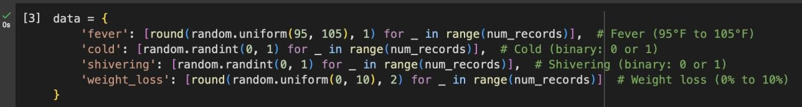

* + Four different sets of random data for the symtoms:
    1. Fever : Random floating-point values between 95 ° F and 105° F.
    2. Cold: Random integer values od 0( no cold) or 1(cold present).
    3. Shivering : Random integer value of 0(no shivering) or 1(shivering present).
    4. Weight_loss : Random float values representing a percentage of body weight lost.

# Creating a DataFrame:

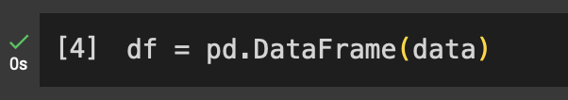

* + We create a pandas DataFrame to store and manage our generated data. A DataFrame is like a table where rows represent records and columns represent symptoms.

# ​Defining the sorting Functions:

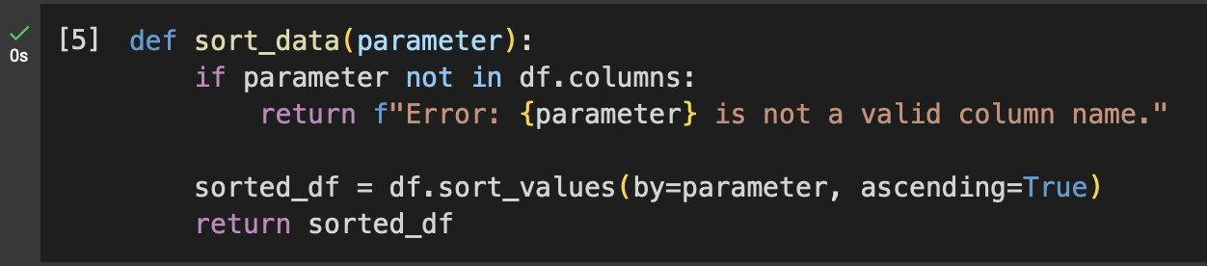

* + We define a function sort_data to sort the DataFrame based on a parameter.
  + First, the function checks if the parameter entered by the user exists as a column in the DataFrame.
  + If the parameter is valid, it sorts the data in ascending order using the pandas sort_values method.
  + The sorted DataFrame is then returned.

# Main Block for User Interaction:

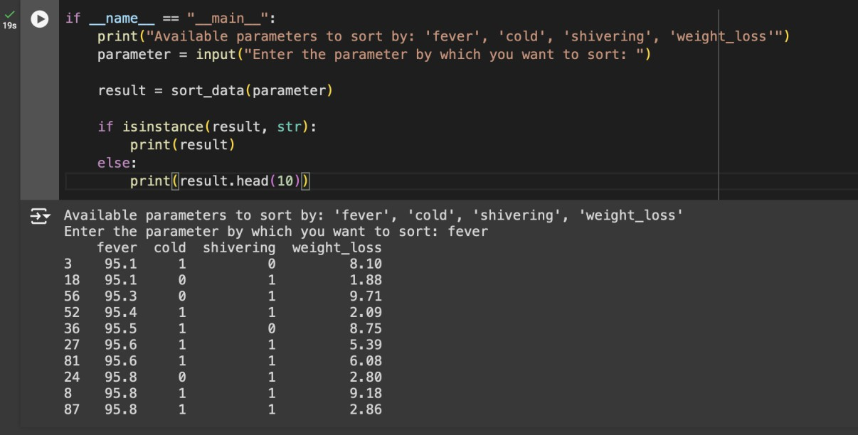

* + In this, the user chose to sort by the fever parameter, and the program displays the top 10 records with the lowest fever temperatures.

**Problem Statement2 :** Generate a model to represent interest calculations of a Bank account where the process of calculating interest for 6 months is a. Find minimum balance for each month b. Make a total of all minimum balances c. Calculate interest based on interest rate d. Divide interest by 12 to find one-month interest e. Multiply interest by 6 to show interest in the account. Generate a model to represent transactions and interest calculations for 6 months.

# Functions to calculate minimum balance:

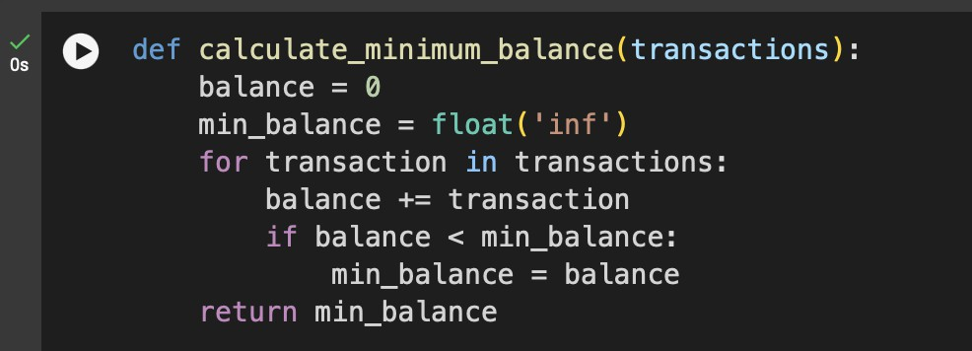

* + This function takes a list of transaction for a month .
  + It starts with a balance of 0 and iterates through each transaction, adjusting the balance accordingly
  + It keeps track of the minimum balances encountered during the month.
  + At the end of the loop, it returns the minimum balance.

# Functions to calculate interest:

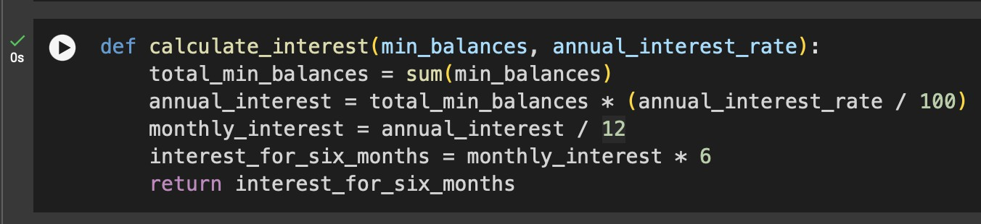

* + The function receives a list of minimum balances for the 6 months and the annual interest rate.
  + Total of minimum balances: It sums up the minimum balance.
  + Annual interest: The interest is calculated by multiplying the total minimum balance by the annual interest rate.
  + Monthly interest: The annual interest is divided by 12 to get the interest for one month.
  + Interest for 6 months: The monthly interest is multiplied by 6 to get the interest over the 6-month period.

# Main functions to simulate transactions and interest calculation:

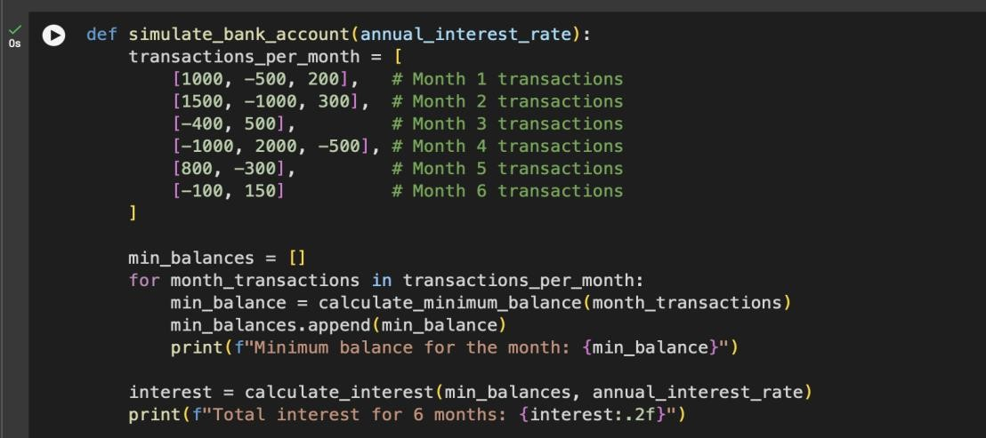

* + This function represents the transactions for each of the 6 months using a list of lists, where each inner list contains transactions for a specific month.
  + It loops through each month’s transactions, calculates the minimum balance using the calculate_minimum_balance function, and stores it in a list.
  + Once the minimum balances for all months are calculated, it calls the calculate_interest function to compute the total interest for 6 months based on the given annual interest rate.
  + The interest is then pinned.

# Main block to run the program:

* + The program starts by asking the user to input the annual interest rate.
  + It then calls the simulate_bank_account function, passing the interest rate to simulate the transactions and calculate the interest.

This program calculates the minimum balance for each month from the given transaction and then computes the total interest for 6 months based on the annual interest rate.